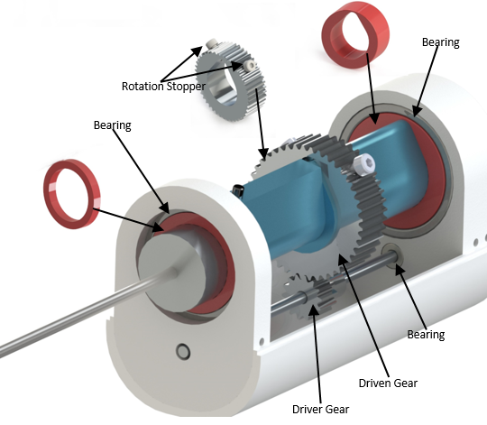

*Fig. 4:* *Components of the Shaver Mechanism*

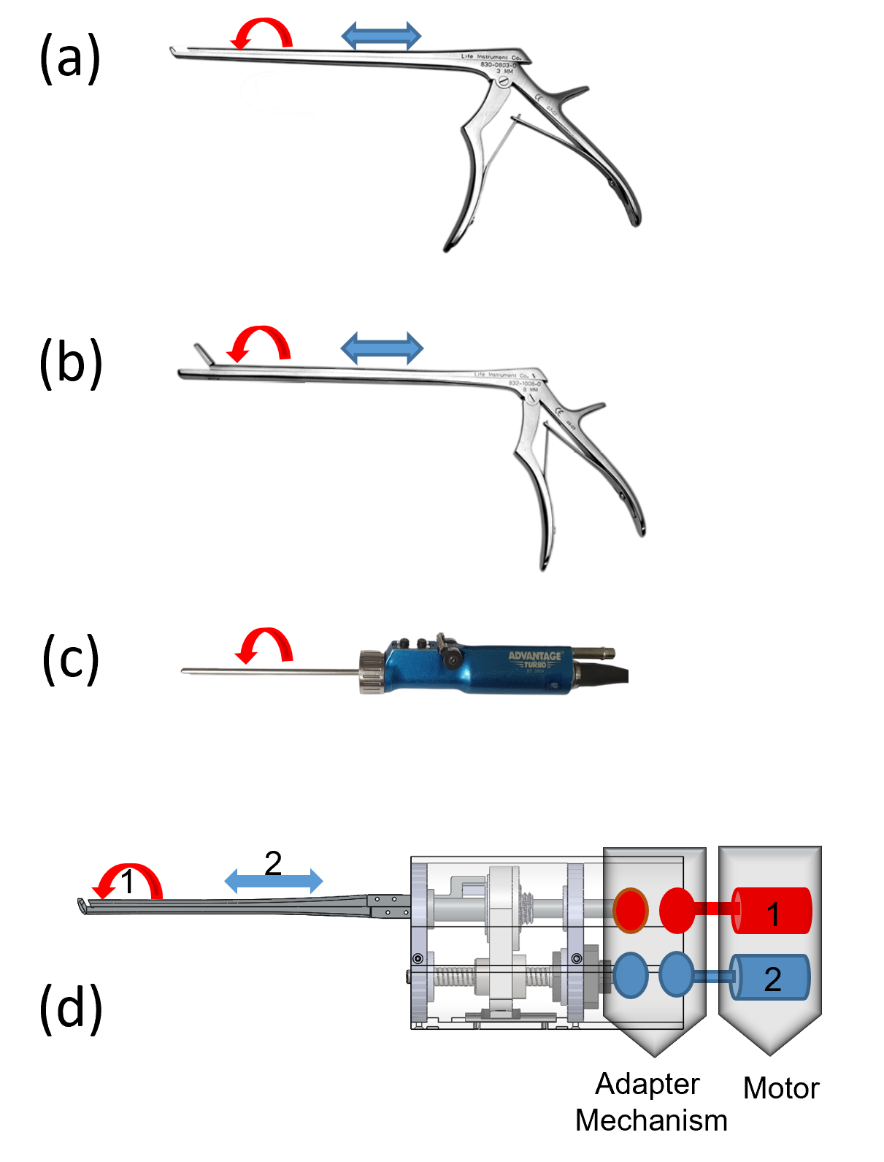

*Fig. 2:* *Instruments Used in Bess, (a) Punch, (b) Pituitary, (c) Shaver, and (d) Stationary Motor Position, Planned Adapter Mechanism and Their Required DoFs*

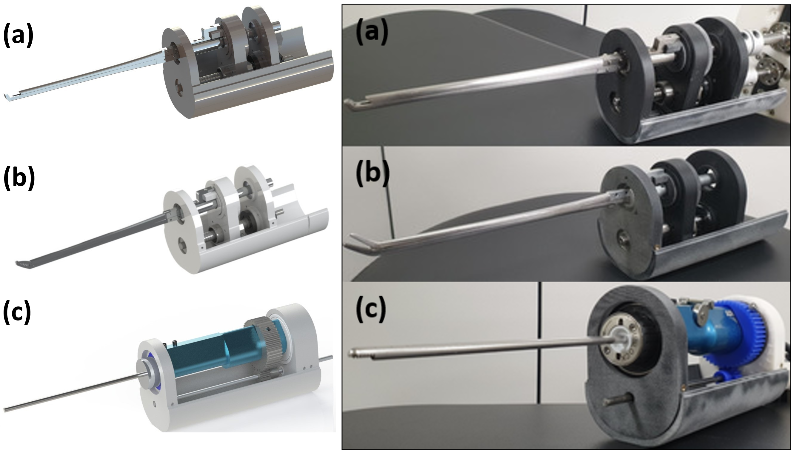

*Fig. 5:* *The Prototypes and CAD Renders of (a) Punch, (b) Pituitary and (c) Shaver*

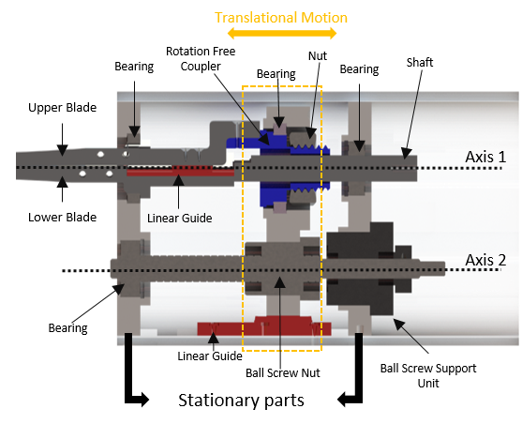

*Fig. 3:* *Cross-Section of the Punch/Pituitary Mechanism*

*Fig. 2 - (a) Punch, (b) Pituitary, (c) Shaver, (d) Stationary Motor Position, Planned Adapter Mechanism and Their Required DoFs*